Appendix A
Instructions for assembly
- Cut two 4 cm segments off the pipe insulator (A, B).
- Remove the adhesive take from the first segment and adhere the edges together (C).
- Encircle the second segment around the first, adhered, segment. Use glue to secure the edges of the second segment to the body of the first segment. The inner circle represents the perineal body, and the outer circle will represent the internal anal sphincter (D).
- With scissors poke a hole through bottom foam segment perpendicular to axis of model, proximal to one end (E, F).
- Use needle drivers to pull the caulk saver segment through hole to represent the external anal sphincter (G, H, I).
- Cut one finger from a rubber work glove. Glue this onto the bottom of the proximal end of the model to represent the rectal mucosa (J, K).
- Cut the desired degree of laceration into the model using scissors: Second degree (L), third degree (M), fourth degree (N)
- Stabilize the model prior to utilization.

Pipe Stand Instructions
- Take a wooden board and use flat headed pins to attach the 1-inch diameter pipe base grounder to the board. Use an extra pin behind the grounder to attach rubber bands to (P, Q, R).
- Place the 1-inch diameter pipe elbow into the grounder (S, T).
- Affix your model to the stand (U).
- Place a marker that has a clip on the cap with the clip side distal to the repair site on the ridges created by the outer foam layer (U).
- Place rubber bands sequentially down the model and around the markers (U).
- Place one rubber band through the marker cap clips and secure it to the pin (U).

A B
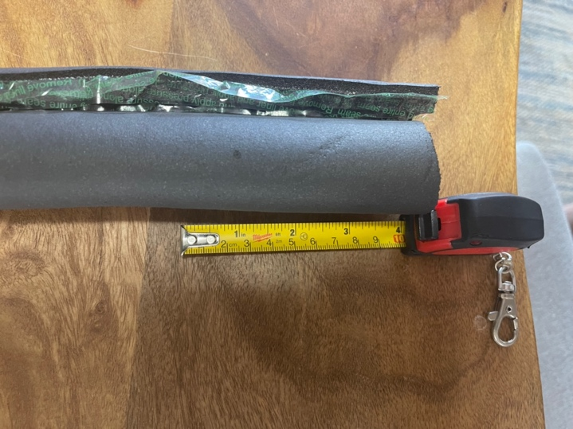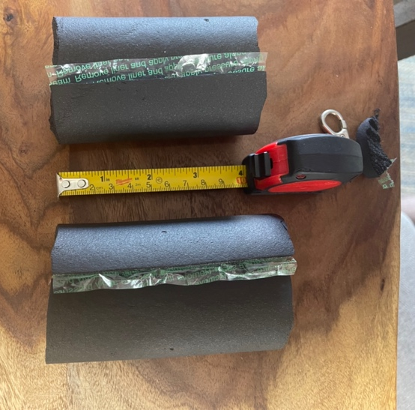

C D
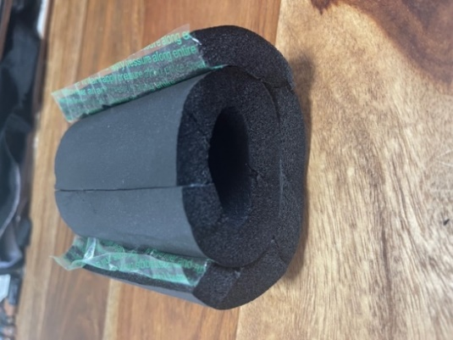
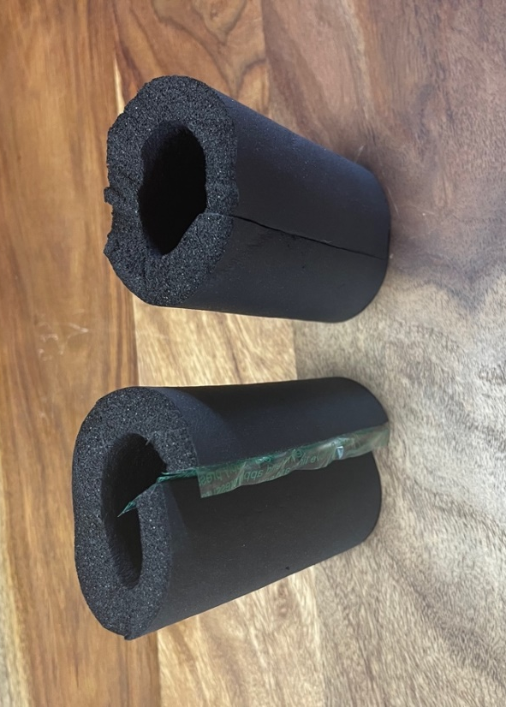

E F
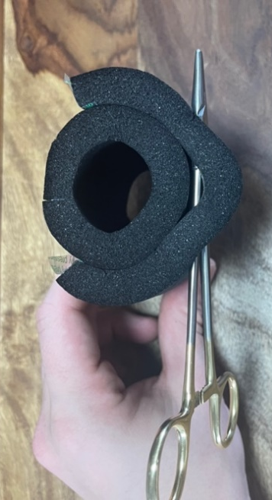
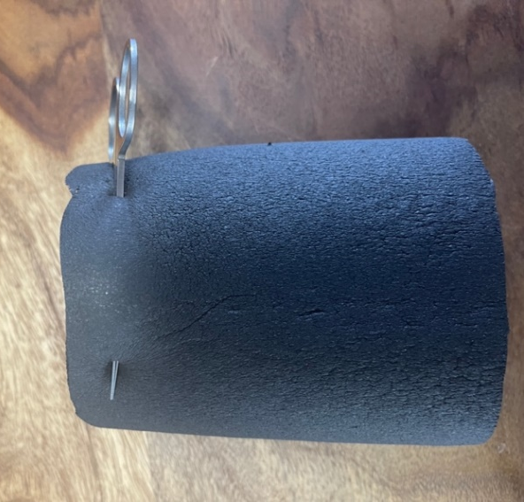
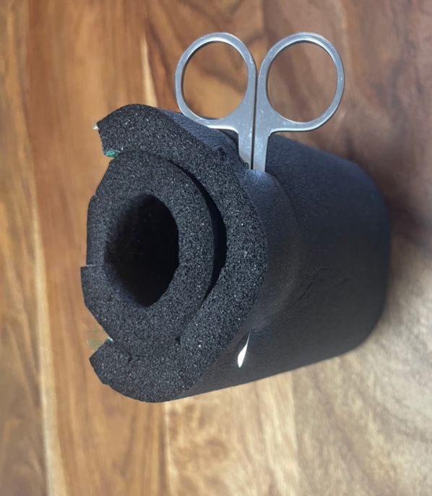
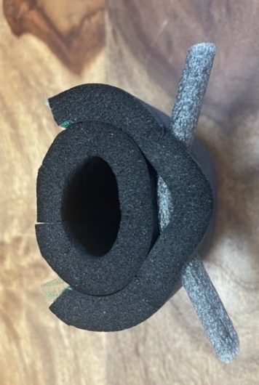
G H

I
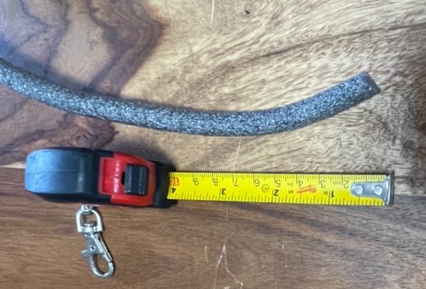

J
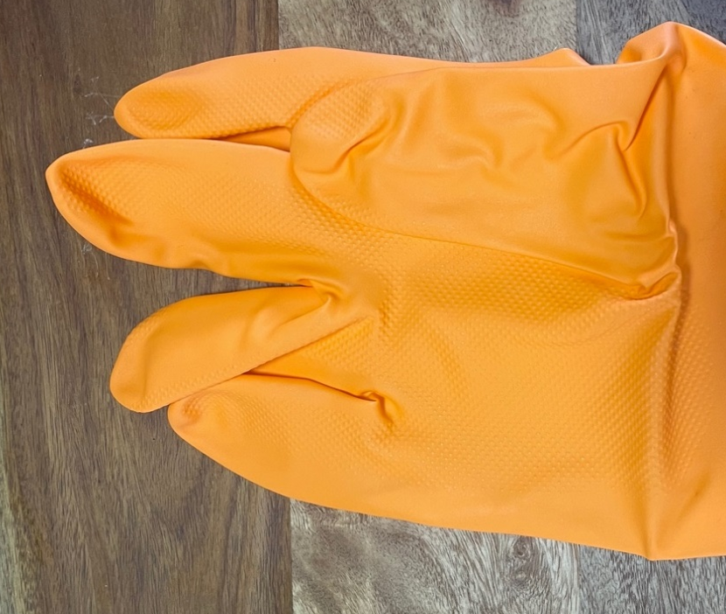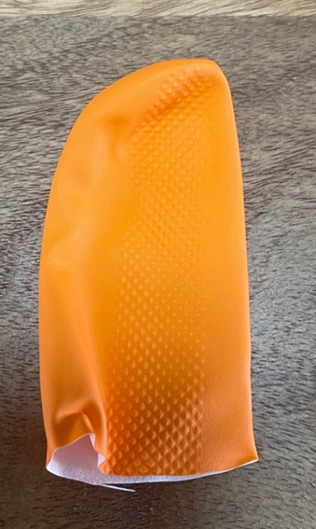

K
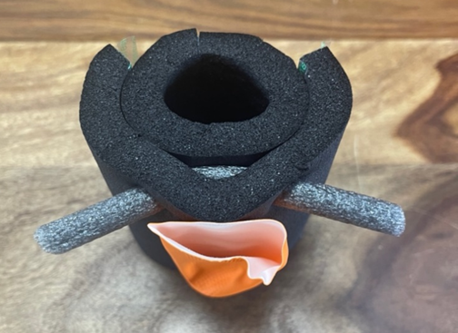
L M
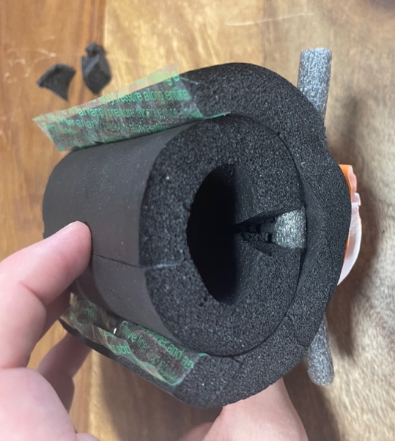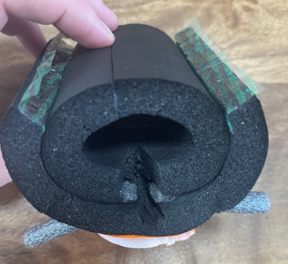

N
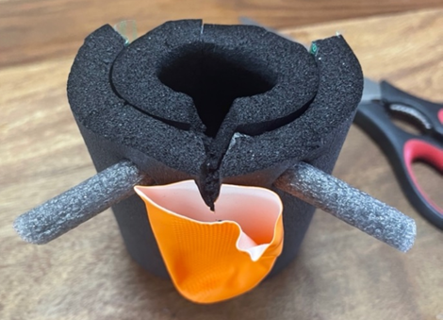
P Q R
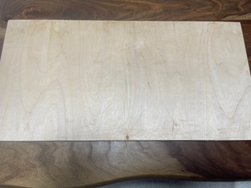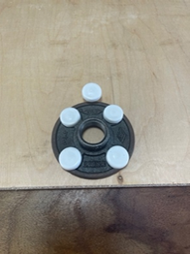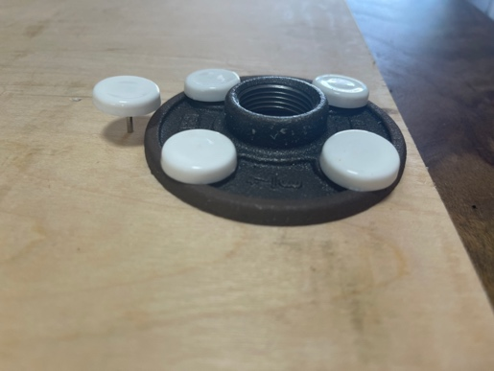

S T
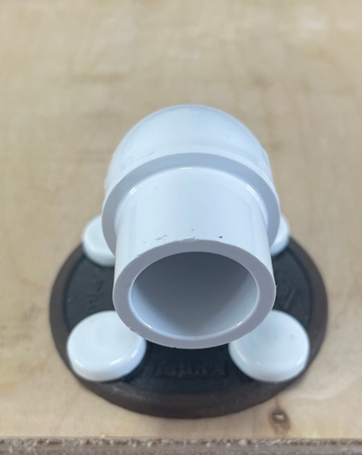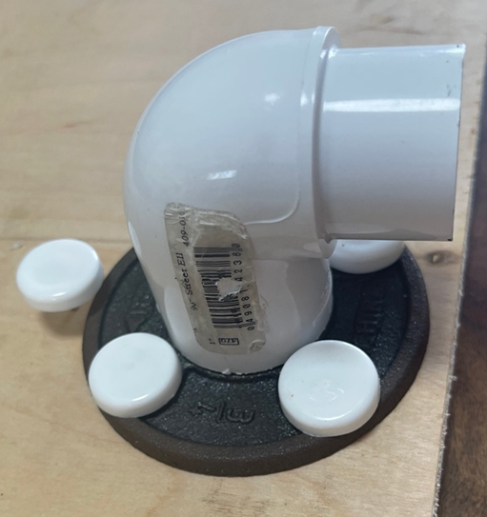

U
